##### Reflection on Learning:

* My understanding of the Support Vector Machine (SVM) is that it is an algorithm that uses Supervised Machine Learning to find a hyperplane in N-dimensional space where N is the number of features. Its application to image classification is its ability to be applied to classification and regression tasks. It is an effective and efficient algorithm that makes it practical for these types of problems.
* The data preparation step was kind of long and tedious. I was able to find and download a dataset of cats and dogs to use in the model training. An SVM classifier was used to train the model on extracted features. The test data set was used for evaluations as the model made predictions. An accuracy score and classification report were generated for reference.
* I faced a lot of challenges with getting the code to run properly and ensuring that I had the necessary libraries and data. I addressed these problems through a tedious process of debugging and finding the correct tools to function. The model's performance seemed to do well on the small and simple dataset.

Inclusion of Visuals:

* 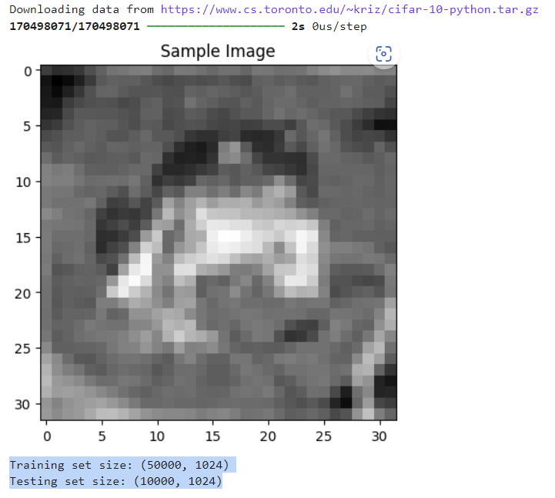.
* This is a visual of an image from the CIFAR-10 dataset that was converted to a gray scale and flattened. Thisis a critical part of preprocessing that allows for the algorithms to be applied effectively.

##### Critical Analysis

* different scenario. There are many different reasons to use SVM. It can be very useful when there is a large number of features and also reserves memory through its support vectors. Custom Kernel functions can be specified for the decision function such as RBF, Linear and polynomial functions. Data is either linearly separable or non-linearly separable. Linearly separable data can be shown as either a line or a hyperplane that separates the data. A polynomial function of input features can separate data that is not linearly separable. I was not able to fully visualize some results and had to sacrifice insights for the sake of time. There are several different scenarios that SVM can be applied to enhance productivity such as handwriting recognition. It is also used for enhancing security with intrusion and fraud detection. A more common application that most everyone is familiar with would be the facial recognition.

References

Kaggle. (n.d.). Run data science & machine learning code online. Retrieved June 20, 2024, from <https://www.kaggle.com/code?language=Python>